The HESS Collective ERP Program
Information Request to Solutions Partners
Sent on November 4, 2020

The following is a brief and focused request for information from the members of the HESS Consortium ERP Collective. As you know, we have shared your RFP responses with our Collective working groups. The information that you provide based on the questions below will aid the working groups of the Collective to make their decision on our ERP/SIS platform and implementation provider. Please answer the questions below and send them to keith.fowlkes@hessconsortium.org on or before Wednesday, December 16, 2020.

- Please name your recommended implementation partner(s) for your work with the HESS Collective institutions and give information on the company and their services.
- What other shared services consortiums have you worked with in the past and how have to address the needs of a diversity of small and mid-sized institution needs? Please give references and contacts as possible.
- How will you address a system-approach to meet the affordability and maintenance factors for small and large institutions within the HESS Collective? (e.g. multi-tenant vs. single tenant vs. multi-instance, other?)
- We are interested in the core functionality of your solution for four (4) primary areas – financial/accounting, human resources / payroll, student financial aid and student information systems / student course and records management. For the sake of your response to this information request, please list all components that would be core to these areas and use layout on page 3 as an example format.
*Please remember that you must meet the functional and affordability needs for all sizes of the institutional member participants as well new incoming members of the Collective.
- Please recommend your approach of how the Collective would best license your solution. Would a single licensing point be preferable over direct licensing with the individual institutions? How would either of these approaches save our institutions money? Please explain. See page 3.
- Please give details about auxiliary software products that would be partially or completely replaced/discontinued with the use of your ERP/SIS solution. (e.g. reporting, analytics, records delivery, workflow, student aid, housing, etc.) For example, give an overview of software that is used in an Ellucian Banner operation that could be displaced/ discontinued by moving to your product.
- Please give details about staff positions/roles that could be repurposed if an institution chose your ERP/SIS solution.
- How could we best evaluate a return on investment (ROI) to our member institutions over the course of 10-years using your specific solution and implementation/support provider? Please give a specific example how our member institutions could see a payback and savings over a 10-year contract.
- Would your company and implementation partner entertain a long-term contract agreement – 10 or more years? How would a long-term contract affect price for our members?
- If selected, would your company provide a point customer success person to address the needs of member institutions within the HESS Collective? Please explain what this person would do to address the needs of the participating institutions of the Collective as well as onboarding new members.
- If selected, how will you and your selected implementation partner assist the HESS Collective in the gathering and archival process of each implementation for our institutions and help to create a resource to lower migration, implementation and integration costs for future members of the Collective? Explain how you would assist us in this important task.
- What additional value-added services could you provide to current and potential HESS Collective members and/or the HESS Consortium to incentivize our decision-making in going with your solution and implementation partner.
- As you know, a major value of the HESS Collective to the selected solution provider is the added security and safety in working with a group of like-minded institutions who have experience in implementing your solution. How will you work with the HESS Collective to promote this to new potential institutions looking at your solution and services?
- Once again, please understand that there is a diversity of institutions in the HESS Collective that makes the pricing structure difficult to address – size, staffing, technical ability, etc. In order to evaluate your solution and implementation costs, we must have a relatively accurate understanding of what would be offered to the variety of institution sizes in the Collective. Please see page 3 for the general outline format.
We ask that you and your implementation partner(s) create a simple pricing structure (using on the HESS/E&I contract vehicle) that would follow this general reporting outline. Please note that we expect the pricing to reflect not only the institutions that are part of the Collective now but the potential institutions to come in the future. As the Collective grows by word of mouth from our participating members, how could current members benefit by helping grow participation? We currently have a potential of 6 pilot institutions but are beginning to build Phase 2 and 3 now.
CURRENT AVERAGES FOR ERP HESS COLLECTIVE PARTICPANTS PROFILE (missing data on 2 schools)
 |  | Your current number  of FTE students  (latest IPEDS) | CURRENT ANNUAL MAINTENANCE FOR HESS COLLECTIVE MEMBERS’ CORE ERP SOFTWARE  (finance/accounting, SIS, HCM and student financial aid)
Averages: |  | 2,357 | $ 213,915.11
High: |  | 5,600 | $ 350,000.00
Low: |  | 479 | $ 36,000.00
Total across all members: |  | 66,007 | $ 5,989,623.00
Total Functional Related Staff Members across all participating institutions
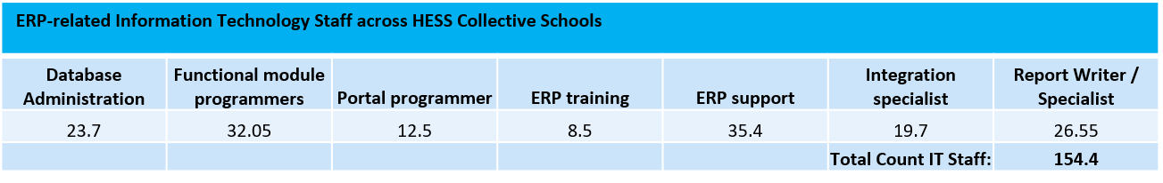

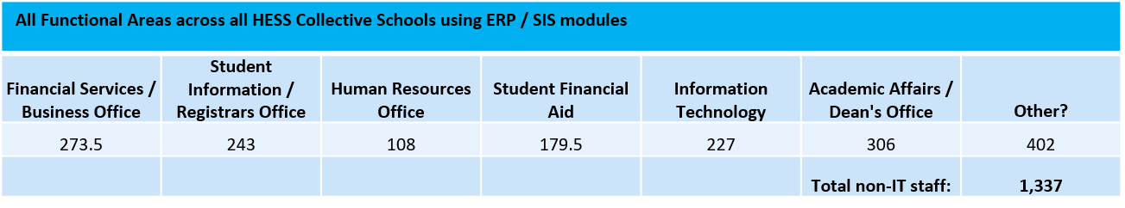

Please read the following page for instructions on providing budgetary pricing to the HESS Collective.
Please see Page 4 for our target timeline for the Collective and our activities.
BUDGETARY PRICING STRUCTURE REQUEST

The major objective in this section is to help us simply evaluate recommended product model “bundles” for the institution size and projected needs within each implemented solution scenario. For example, a small institution may not require a e-procurement solution while a larger institution may wish to include this component. We are looking for your recommendations while keeping in mind institution size and resources available. Optional add-ins will be helpful for smaller institutions that have the resources and need for that functionality.

Please follow this very basic structure outline for our software and budgetary pricing evaluation needs:
Recommended HESS Collective Member Tiers  (there will be variations in these tier numbers for some members) | Recommended Bundled Applications w/ Pricing per seat | Optional Add-on Applications Available with Pricing per seat | Estimated budgetary Implementation Costs per recommended bundles  (for implementation partners)
ERP IT Staff: 3-10 /  Admin Dept seats: 12-25  Student FTE: 400-1200 | Financial modules:  Student Fin Aid modules:  HCM modules:  Projected SIS modules: | Financial modules:  Student Fin Aid modules:  HCM modules:  Projected SIS modules: | Financial modules:  Student Fin Aid modules:  HCM modules:  Projected SIS modules:
ERP IT Staff: 3-10 /  Admin Dept seats: 26-39  Student FTE: 1201-1800 | Financial modules:  Student Fin Aid modules:  HCM modules:  Projected SIS modules: | Financial modules:  Student Fin Aid modules:  HCM modules:  Projected SIS modules: | Financial modules:  Student Fin Aid modules:  HCM modules:  Projected SIS modules:
ERP IT Staff: 3-12/  Admin Dept seats: 40-60  Student FTE: 1801-2200 | Financial modules:  Student Fin Aid modules:  HCM modules:  Projected SIS modules: | Financial modules:  Student Fin Aid modules:  HCM modules:  Projected SIS modules: | Financial modules:  Student Fin Aid modules:  HCM modules:  Projected SIS modules:
ERP IT Staff: 10-20 /  Admin Dept seats: 61-89  Student FTE: 2201-3000 | Financial modules:  Student Fin Aid modules:  HCM modules:  Projected SIS modules: | Financial modules:  Student Fin Aid modules:  HCM modules:  Projected SIS modules: | Financial modules:  Student Fin Aid modules:  HCM modules:  Projected SIS modules:
ERP IT Staff: 10-20 /  Admin Dept seats: 90-125  Student FTE: 3001-3500 | Financial modules:  Student Fin Aid modules:  HCM modules:  Projected SIS modules: | Financial modules:  Student Fin Aid modules:  HCM modules:  Projected SIS modules: | Financial modules:  Student Fin Aid modules:  HCM modules:  Projected SIS modules:
ERP IT Staff: 20-25  Admin Dept Staff: 126-170  Student FTE: 3501-4000 | Financial modules:  Student Fin Aid modules:  HCM modules:  Projected SIS modules: | Financial modules:  Student Fin Aid modules:  HCM modules:  Projected SIS modules: | Financial modules:  Student Fin Aid modules:  HCM modules:  Projected SIS modules:
ERP IT Staff: 26+  Admin Dept Staff: 171+  Student FTE: 4000-6000+ | Financial modules:  Student Fin Aid modules:  HCM modules:  Projected SIS modules: | Financial modules:  Student Fin Aid modules:  HCM modules:  Projected SIS modules: | Financial modules:  Student Fin Aid modules:  HCM modules:  Projected SIS modules:
These tiers are based on the various staff sizes in the initial group of Collective institutions. Please understand that we are requesting budgetary figures, and costs may have some variability based on institution. Having sold and implemented your solutions in various sizes of institutions, you know a basic average cost for implementations of these sizes within a certain standard deviation. If you wish to collapse the tiers shown here, please explain how this addresses the various functional and cost needs of the Collective membership now and in the future. Please include a legend of each of the recommended software you have listed above with detail on what functionality that software addresses and if it can be removed from the bundle if the institution feels it is unnecessary to their operation.

We do expect questions so please email Keith Fowlkes at keith.fowlkes@hessconsortium.org with your inquiries.

